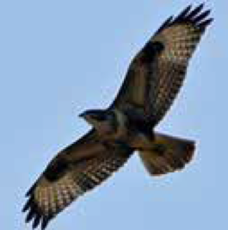
Plumpton & East Chiltington Wildlife Group

Why not become a member? Anyone living in Plumpton or East Chiltington parishes is welcome.

Membership costs just £5.00 a year per household. For this, you get:

- opportunities to take part in projects and surveys – from meadow raking to butterfly counting, measuring ancient trees and dormouse surveying
- invitations to join our field trips and special events
- the chance to meet and work with like-minded people.

If you would like to become a member, please complete the form below and email it to plumptonwildlife@gmail.com (or post to PECWG, Dyke Nook, Station Road, Plumpton Green, Lewes BN7 3BZ). It is easier for us if you pay the £5 subscription by BACS transfer: Sort code: 09-01-28; Account no: 97009189; give your surname as reference. Note, it is a business account. If you prefer to pay by cheque or cash, please see the Treasurer (Kate Gold, at the above address).

Names of those in your household ........................................................................................
................................................................................................................................................
................................................................................................................................................
Address ..................................................................................................................................
................................................................................................................................................
........................................................................Postcode ........................................................
Email .....................................................................................................................................
Telephone .............................................................................................................................
Please tell us if you have any special interests or skills to offer
...............................................................................................................................................
...............................................................................................................................................

e plumptonwildlife@gmail.com w https://plumptonwildlifegroup.weebly.com/

